Error Correction vs Error Detection
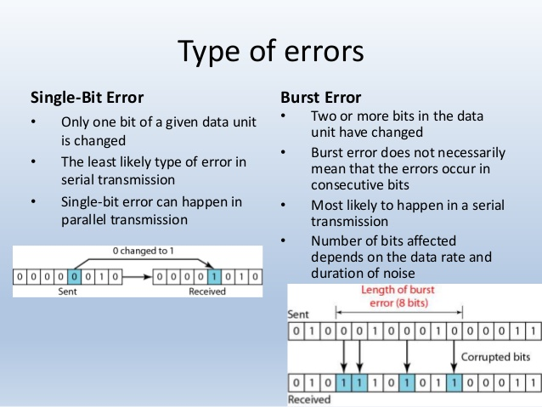
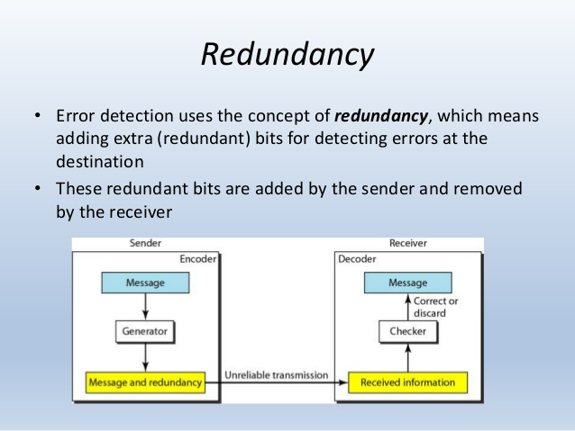
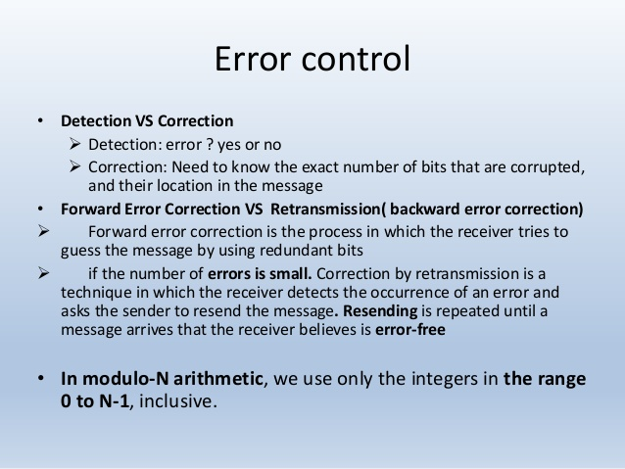
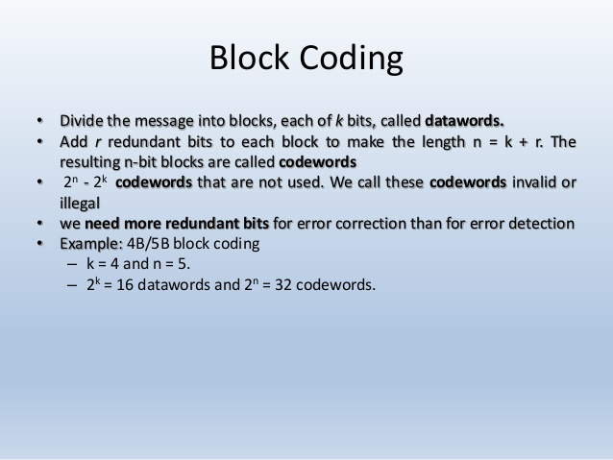
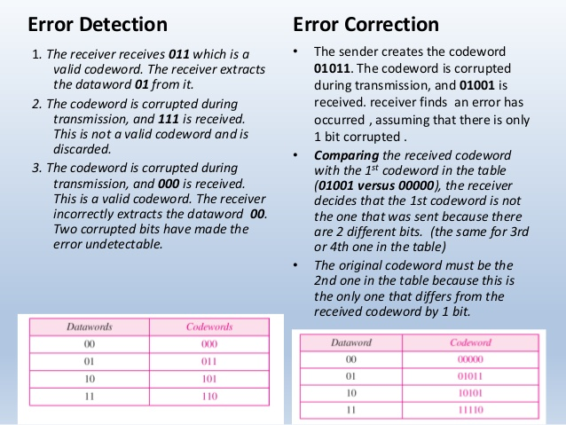
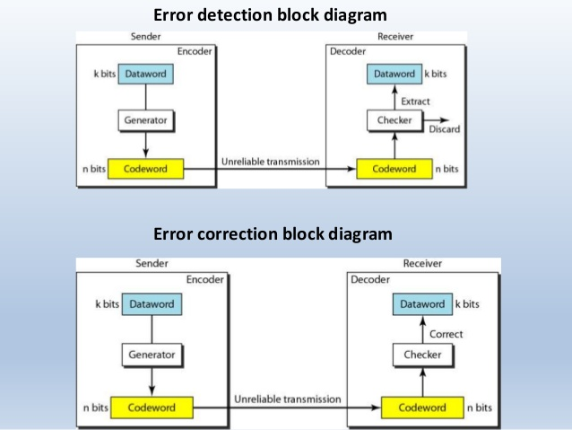

Parity Schemes : A parity bit is an error detection mechanism . A parity bit is an extra bit transmitted with a data item, chose to give the resulting bit seven or odd parity. Parity refers to the number of bits set to 1 in the data item.
There are 2 types of parity

- Even parity – an even number of bits are 1 Even parity – data: 10010001, parity bit

- Odd parity – an odd number of bits are 1 Odd parity – data: 10010111, parity bit 0

Error detection codes − are used to detect the errorss present in the received data bitstreambitstream. These codes contain some bitss, which are included appendedappended to the original bit stream. These codes detect the error, if it is occurred during transmission of the original data bitstreambitstream. Example − Parity code, Hamming code.
Error correction codes − are used to correct the errorss present in the received data bitstreambitstream so that, we will get the original data. Error correction codes also use the similar strategy of error detection codes.Example − Hamming code.
Therefore, to detect and correct the errors, additional bitss are appended to the data bits at the time of transmission.

Parity Code
It is easy to include appendappend one parity bit either to the left of MSB or to the right of LSB of original bit stream. There are two types of parity codes, namely even parity code and odd parity code based on the type of parity being chosen.

Even Parity Code
The value of even parity bit should be zero, if even number of ones present in the binary code. Otherwise, it should be one. So that, even number of ones present in even parity code. Even parity code contains the data bits and even parity bit.
The following table shows the even parity codes corresponding to each 3-bit binary code. Here, the even parity bit is included to the right of LSB of binary code.

Binary Code | Even Parity bit | Even Parity Code
000 | 0 | 0000
001 | 1 | 0011
010 | 1 | 0101
011 | 0 | 0110
100 | 1 | 1001
101 | 0 | 1010
110 | 0 | 1100
111 | 1 | 1111

Odd Parity Code
The value of odd parity bit should be zero, if odd number of ones present in the binary code. Otherwise, it should be one. So that, odd number of ones present in odd parity code. Odd parity code contains the data bits and odd parity bit.
The following table shows the odd parity codes corresponding to each 3-bit binary code. Here, the odd parity bit is included to the right of LSB of binary code.
Binary Code | Odd Parity bit | Odd Parity Code
000 | 1 | 0001
001 | 0 | 0010
010 | 0 | 0100
011 | 1 | 0111
100 | 0 | 1000
101 | 1 | 1011
110 | 1 | 1101
111 | 0 | 1110

